February 9, 2017

Specialized Press Contact
Thomas Lange
Coating Additives
Phone +49 201 173-3050
thomas.lange2@evonik.com

Evonik Resource Efficiency GmbH
Rellinghauser Straße 1-11
45128 Essen
Phone +49 201 177-01
Fax +49 201 177-3475
www.evonik.com

Supervisory Board
Dr. Ralph Sven Kaufmann, Chairman

Executive Board
Dr. Claus Rettig, Chairman
Dr. Johannes Ohmer,
Simone Hildmann,
Alexandra Schwarz

Registered Office: Essen
Register Court: Essen Local Court
Commercial Registry B 25783
VAT ID no. DE 815528487
Evonik establishes leading additive supplier
for the coatings industry

- New business line with globally unique technology platform
- Solutions for almost any formulation challenge in the paints and coatings industry
- Strong business counts on excellent and creative solutions

Evonik Industries is transforming into one of the leading suppliers of additives for the coatings industry. The acquisition of Air Products’ Performance Materials division that was completed in early January made a key contribution to this. Effective January 3, 2017, Evonik merged its Coating Additives Business Line, the coatings business of its Silica Business Line, and the specialty additives branch of Air Products with a focus on substrate wetting additives. Dr. Claus Rettig, Chairman of the Board of Management, Evonik Resource Efficiency GmbH, says, “The result is one of the world’s leading additives suppliers for the coatings industry. Our technology platform is unlike any other in the world. It allows us to develop innovative solutions for just about any formulation challenge in the paints and coatings industry.”

The products of the new business line complement each other well. The broad range of additives for water-based coatings under the TEGO® brand will be combined with AEROSIL® silica to control the rheological properties of paints and coatings as well as the ACEMATT® matting agent. The acquired substrate wetting agents under the SURFYNOL® and DYNOLTM brand names and additional expertise on the formulation of automotive coatings in particular are the perfect complement to the coatings additives portfolio.

To Dr. Gaetano Blanda, head of the new business line, joining forces to create added value for customers and Evonik is one of the most important goals. He wants to further strengthen the unit and places his trust in the excellently qualified employees. Some 450 employees at around 30 production and research sites of the new business line currently offer about 500 products.

Other than the expanded product portfolio, the acquisition of the Performance Materials division of Air Products will not initially mean any changes for customers. Blanda promises: “Contact persons and existing contracts will remain unaffected. It is our aim to provide our customers in the coatings industry with the best possible long-term product and service portfolio.

Evonik merges three successful units in the new Coating Additives Business Line:

Part of the former specialty additives business of the Performance Materials division of Air Products
This former division of Air Products has been an important supplier of specialty additive technologies for the paints and coatings industry for over 30 years. The business offers a large number of wetting agents, defoamers, grinding agents, and dispersion additives that help formulators achieve the perfect finish. Some of the most important applications are in the automotive industry. The challenge facing formulators of automotive finishes is producing coatings that are environmentally friendly, cost-effective, and free of defects.
The most well-known products of this business include SURFYNOL® and DYNOLTM.

Silica Coatings
Among its other achievements, the coatings business of the Silica Business Line of Evonik produces two world-renowned product groups for the coatings industry: AEROSIL® and ACEMATT®.
As components of coatings and paints, AEROSIL® fumed silicas are primarily used for controlling rheological properties, as thickeners, thixotropic agents and anti-settling agents, and for improving anti-corrosion properties.
ACEMATT® silica-based matting agents can alter the surface of a coating in order to scatter incident light in defined ways. Invisible to the human eye, the matting agent particles protrude from the coating, and do not significantly alter either the color of the coating or that of the substrate when used in clear varnishes.

Coating Additives
The former Coating Additives Business Line of Evonik leads the additives market for water-based finishes. The business line’s TEGO® brand offers a unique range of products for customers in the coatings and printing inks industries. Its over 200 products allow formulators to selectively adjust the functional properties of coatings.

In addition to its familiar defoamers and deaerators, the additive portfolio also includes wetting agents, dispersion additives, leveling additives, substrate wetting additives, radiation curing additives, rheological additives, and hydrophobizing agents. Rounding out the product portfolio are cobinders, nanocomposites, and specialty resins.

Visit us at the European Coatings Show in Nuremberg, April 4 – 6, 2017 (hall 7A, booth 323).

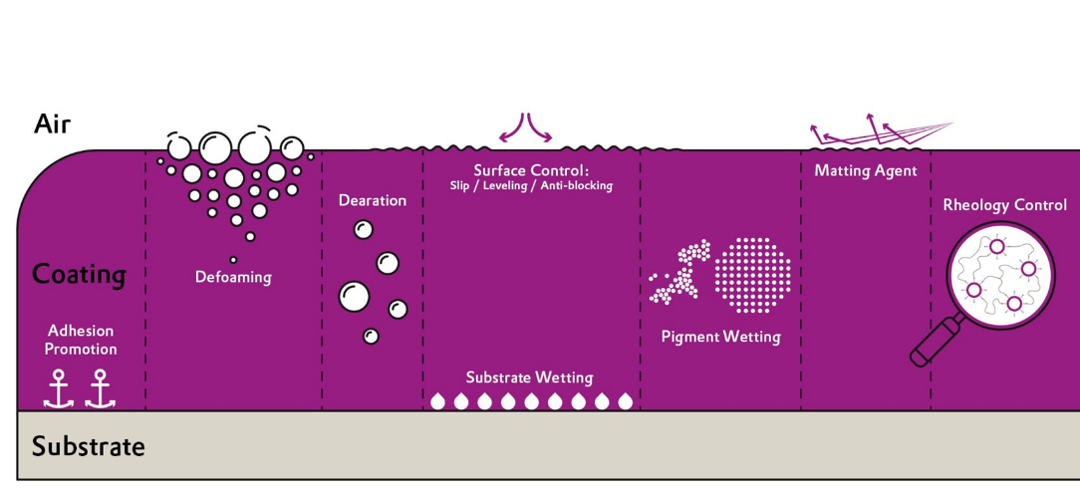

Caption: The right solution for every problem: key functional properties at a glance.

Company information
Evonik, the creative industrial group from Germany, is one of the world leaders in specialty chemicals, operating in the Nutrition & Care, Resource Efficiency and Performance Materials segments. The company benefits from its innovative prowess and integrated technology platforms. In 2015 more than 33,500 employees generated sales of around €13.5 billion and an operating profit (adjusted EBITDA) of about €2.47 billion.

About Resource Efficiency
The Resource Efficiency segment is led by Evonik Resource Efficiency GmbH and supplies high performance materials for environmentally friendly as well as energy-efficient systems to the automotive, paints & coatings, adhesives, construction, and many other industries. This segment employed about 8,600 employees, and generated sales of around €4.3 billion in 2015.

Disclaimer
In so far as forecasts or expectations are expressed in this press release or where our statements concern the future, these forecasts, expectations or statements may involve known or unknown risks and uncertainties. Actual results or developments may vary, depending on changes in the operating environment. Neither Evonik Industries AG nor its group companies assume an obligation to update the forecasts, expectations or statements contained in this release.

